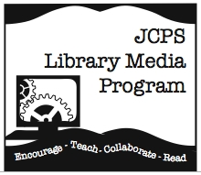MC900048773[1]MC900056833[1]MC900078622[1]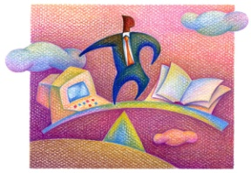

1. **A**sk - What do I need to know ?

2. **A**ccess - Where can I find the answers

to my questions?

3. **A**nalyze - Is this resource what I really need? Does it answer my questions?

4. **A**pply - Put all the information together for the project or task.

5. **A**ssess - Did I follow the directions

well? Did I do a good job on my assignment or task?

JCPS Information Process Model

**Follow the 5A’s Inquiry Process**

The 21st Century Fluency Project

www.fluency21.com