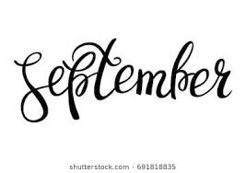

September Newsletter 2020

Hello Parents!

We are happy to be in the second month of the new school year and are looking forward to continued progress. Thank you all for all your support and feedback so far, and please continue to encourage learning at home by reading and practicing social skills with your children! We continue to work on sharing nicely with others, engaging in play with peers, and interaction during read aloud. We have been working hard on appropriate school behaviors and getting back into a routine. The monthly newsletters will be shared with you at the beginning of each month and are available to view at our classroom webpage. As always, please feel free to write in the communication folders to give me an update on any important information regarding your child. If you have any immediate questions or concerns, please email or call me at the number below!

**Important dates to remember in September:**

**September 7th: Labor Day NO SCHOOL**

**September 16th: 2 hour Early Release**

Sincerely,

Becky Backes

[rebekah.backes@jcschools.us](mailto:rebekah.backes@jcschools.us)

(573) 659-3175

