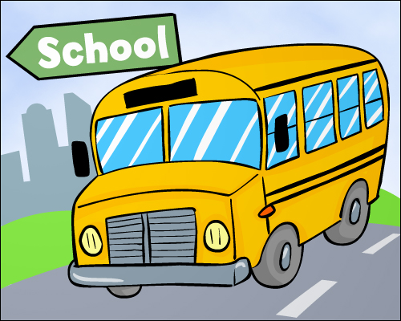

**Third Grade News**

**Ms. Maddox’s Class**

**October 25, 2024**

I hope you will encourage your child to participate in the Pizza Hut Book It reading program this month. The November record-keeping calendars should be coming home with your child. They are required to read for 20 minutes on most days during the month, and in return they receive a coupon for a free personal pan pizza when the calendar is returned with a parent signature. Reading = Eating? Sounds like a win/win situation to me! ☺

REMINDER THAT CONFERENCES ARE WEDNESDAY THE 6th AND THURSDAY THE 7th. Here is the link to sign up. I will be sending notices next week with your time. If you haven’t signed up, by Monday, I will set you up with a time. I LOOK FORWARD TO SPEAKING WITH YOU!

<https://signup.com/go/eKjdhOv>

**Specials**

**Monday – Art**

**Tuesday – Music**

**Wednesday – PE**

**Thursday – Art**

**Friday - Music**

**Our learning goals for this week are…**

**ELA Unit 4**

*I can draw conclusions and support with textual evidence

*I can decode and identify the meaning of common prefixes and suffixes and knowing how they change the meaning of root words

*I can distinguish the literal and nonliteral meanings of words and phrases in context

*I can use conversational, general academic, and domain-specific words and phrases

*I can read text that is developmentally appropriate and produce evidence of reading

*I can identify the details or facts that support the main idea

*I can describe relationships among events, ideas, concepts,

*I can generate a main idea to support a multiple-paragraph text using a variety of sentence types, including imperative and exclamatory

*I can support the topic sentences within each paragraph with facts and details

*I can categorize, organize, and sequence the supporting details into a text with a clear beginning, middle, and end

*I can address an appropriate audience

*I can write informative/explanatory texts.

ELA Unit 3 test will be on Tuesday.

**Social Studies**: (unit 2)

*I can select and analyze primary and secondary social studies’ sources to determine importance with guidance and support.

* I can use visual tools and informational texts to interpret, draw conclusions, make predictions, and communicate information and ideas with support.

**Science: Unit 3**

*I can obtain and combine information to describe climates in different regions of the world.

*I can represent data in tables and graphs to describe typical weather conditions during a season.

**Math: Unit 3**

*I can demonstrate fluency with addition and subtraction within 1000.

*I can interpret reasonableness of answers using strategies such as rounding.

Guidelines for costumes:

No mask

No fake weapons

No blood/gore

No horror or mature themed characters

!

**November**

|  |  |  |  |  |
| --- | --- | --- | --- | --- |
| **Monday** | Tuesday | Wednesday | Thursday | Friday |
| **28** | **29** | **30**  **Major Savers collection ends** | **31**  **Trunk or treat 1:15** | **1** |
| **4** | **5** | **6**  **P/T Conferences 3-7** | **7**  **P/T Conferences 3-7** | **8** |
| **11**  **No School**  **For students** | **12** | **13** | **14** | **15** |